**COMSATS UNIVERSITY ISLAMABAD, SAHIWAL CAMPUS, COMSATS ROAD OFF GT ROAD, SAHIWAL, PAKISTAN.**

**Project PROPOSAL**

**for**

**Batch Advisory**

(Web App)

Version 1.0

***By***

|  |  |
| --- | --- |
| **Bilal Ahmad** | **CIIT/SP21-BSE-004/SWL** |
| **Javid Irshad** | **CIIT/SP21-BSE-045/SWL** |
| **Saad Ali** | **CIIT/SP21-BSE-029/SWL** |

***Supervisor: Ms. Mubeen Javed***

***Bachelor of Science in Software Engineering (2021-2024)***

**Project Title**

Batch Advisory

(Web App)

**Project Advisor**

***Ms. Mubeen Javed***

### Project Co-Supervisor

**Particulars of the students:**

|  |  |  |  |  |  |
| --- | --- | --- | --- | --- | --- |
| **S. No** | **Registration** | **Name in Full** | **CGPA** | **Email** | **Signatures** |
| 1 | SP21-BSE-004 | Bilal Ahmad | 3.4 | Sp21-bse-004@students.cuisahiwal.edu.pk |  |
| 2 | SP21-BSE-029 | Saad Ali | 2.87 |  |  |
| 3 | SP21-BSE-045 | Javid Irshad | 2.6 |  |  |

### Advisor’s Consent

I Prof. /Dr. /Mr. /Ms. ________________________________________________ am willing to guide these students in all phases of above-mentioned project / thesis as advisor. I have carefully seen the Title and description of the project / thesis and believe that it is of an appropriate difficulty level for the number of students named above.

### Co- Advisor’s Consent

I Prof. /Dr. /Mr. /Ms. ________________________________________________ am willing to guide these students in all phases of above-mentioned project / thesis as advisor. I have carefully seen the Title and description of the project / thesis and believe that it is of an appropriate difficulty level for the number of students named above.

|  |  |
| --- | --- |
| Signatures and Date   |  | | --- | |  |   **Advisor** |
| Signatures and Date   |  | | --- | |  |   **Co-Advisor** |

**SCOPE DOCUMENT REVSION HISTORY**

|  |  |  |
| --- | --- | --- |
| **No.** | **Comment** | **Action** |
|  |  |  |
|  |  |  |
|  |  |  |
|  |  |  |
|  |  |  |
|  |  |  |

Supervisor Signature

Date:

# Contents

Project Co-Supervisor ii

(a) Advisor’s Consent ii

(b) Co- Advisor’s Consent ii

Article II. Contents iv

1. Introduction 1

2. Problem statement 2

3. Problem solution for proposed system 2

4. Related system analysis/literature review 2

5. Advantages/benefits of proposed system 2

6. Scope 2

7. Modules 2

7.1. System Limitations/Constraints 3

8. Software process methodology 3

9. Software and technologies 3

10. Project stakeholders and roles 4

11. Data gathering approach. 4

12. Concepts 4

13. Gantt chart 5

14. Mockups 6

15. Conclusion 7

16. References 7

17. Plagiarism report 8

Table 2: Tools and Technologies for Proposed Project 3

Table 3: project stakeholders 4

Table 4: Team Member Work Division for Proposed Project 4

Figure 1: Gantt-chart 5

Figure 2: login-page 6

Figure 3: application-form-page 6

Figure 4: batch-advisor-dashboard. 7

|  |
| --- |
| **Project Category: (**Select all the major domains of proposed project**)**  **A-** Desktop Application/Information System B**-** Web Application/Web Development  **C- Problem Solving and Artificial Intelligence** D**-**Simulation and Modeling **E-** Smartphone Application  **F-** Image Processing Other (specify category) ____________________________________________ |

**Abstract**

Our project aims to automate the batch advisory system in a university setting by developing two main modules: a Course Recommendation System to help the batch advisor and an Online Application System to facilitate the student. Leveraging React for the frontend and Node.js for the backend, we intend to streamline the course selection process for students and facilitate online application submissions. This project seeks to enhance efficiency, transparency, and overall experience for both students and batch advisors.

# Introduction

This proposal outlines a comprehensive approach to automate the batch advisory system in a university. Manual processes in course recommendation and application handling are time-consuming and error prone. Thus, we aim to address these challenges by implementing modern technologies and intuitive solutions.

# Problem statement

The current batch advisory system in universities faces inefficiencies in course recommendation and application handling. Our software intends to solve these issues by automating processes, improving communication, and integrating real-time features. Implementing these systems will enhance our learning and develop practical skills in software development, data analysis, and system integration.

# Problem solution for proposed system

Our proposed system automates course recommendations based on prerequisites and Scheme of Study (SOS) and facilitates online application submissions. Through React and Node.js, we streamline processes, enhance communication, and integrate real-time features, thus improving efficiency and transparency within the batch advisory system.

# Related system analysis/literature review

There are no related systems available yet.

# Advantages/benefits of proposed system

* Streamlined course selection process for students.
* Improved communication and transparency between students and batch advisors.
* Enhanced efficiency and effectiveness of the batch advisory system.
* Integration with existing university systems and databases.
* Real-time notifications and updates for students and batch advisors.

# Scope

Our project encompasses the development of two main modules: the Course Recommendation System and the Application System. These modules will allow students to view recommended courses, submit applications online, and communicate with batch advisors seamlessly and also allow the batch advisor to help in recommending the courses.

# Modules

**Module 1: Course Recommendation:**

Generates course recommendations based on prerequisites and Scheme of Study (SOS) of students.

**Module 2: Online Application Submission:**

Enables students to submit applications online and communicate with batch advisors.

**Module 3: Authentication for faculty and students**

**Module 4: Notification Component**

## 7.1. System Limitations/Constraints

* Limited access to university data and resources.
* Dependency on external APIs or services for real-time communication features.

# Software process methodology

We will adopt an Agile software development methodology for its flexibility and adaptability.

# Software and technologies

Table 2: Tools and Technologies for Proposed Project

|  |  |  |
| --- | --- | --- |
| Tools | Version | rationale |
| MS Visio | Office 365 | Gantt Chart, Use Case, Incremental Model Diagram, Flowchart, Activity Diagram |
| MS Word 365 | Office 365 | Documentation |
| MS PowerPoint 365 | Office 365 | Presentation |
| VS Code |  | IDE |
| Figma |  | Mockups Creation |
| Git |  | For Version Control |
| Database Management System: PostgreSQL |  | User data and Application Content |
| Frontend: React.js, HTML, CSS, JavaScript |  | Web app development |
| Backend: Node.js, Express.js |  |  |
| Additional Tools: Python for data analysis. |  |  |

# Project stakeholders and roles

Table 3: project stakeholders

|  |  |
| --- | --- |
| **Project Sponsor** | COMSATS University Islamabad, Sahiwal campus |
| **Stakeholder** | * BILAL AHMAD, JAVID IRSHAD, SAAD ALI * Supervisor name: MS Mubeen Javed * Final Year Project Committee: Evaluation of project |

Table 4: Team Member Work Division for Proposed Project

|  |  |  |
| --- | --- | --- |
| **Student Name** | **Student Registration Number** | **Responsibility/ Modules** |
| BILAL AHMAD | SP21-BSE-004 | Components Integration, Handle APIs |
| JAVID IRSHAD | SP21-BSE-045 | Designing and Implementing the Frontend |
| SAAD ALI | SP21-BSE-029 | Implementing the Frontend and sort of API for real time |

# Data gathering approach.

We will employ various approaches such as interviews, and questionnaires review to gather information from the faculty and students also and requirements for the proposed project.

# Concepts

1. **Concept-1: Course Recommendation:**

Machine learning algorithms for course recommendation.

1. **Concept-2: API Integration:**

Incorporating external APIs into the application for additional functionality

1. **Concept-3: Web Application Development:**

Real-time communication protocols for online application submission.

1. **Concept-4: User Interface Design:**

Designing intuitive and user-friendly interfaces for enhanced usability.

# Gantt chart

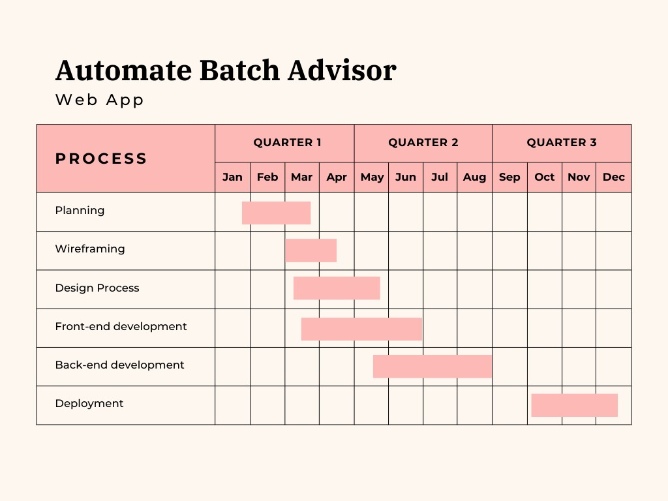

Figure 1: Gantt-chart

# Mockups



Figure 2: login-page



Figure 3: application-form-page



Figure 4: batch-advisor-dashboard.

# Conclusion

In conclusion, our project aims to revolutionize the batch advisory system in the university setting by automating critical processes and leveraging modern technologies. By developing a comprehensive solution encompassing both course recommendation and leave application functionalities, the project seeks to enhance the overall academic advising experience for students and batch advisors.



# References

*BU College of General Studies*. (n.d.). Retrieved from BU College of General Studies: https://www.bu.edu/cgs/resources-for-current-students/academic-advising/student-advisor-responsibilities/

*Depul Edu*. (n.d.). Retrieved from https://offices.depaul.edu/university-registrar/about/Documents/TRAINING%20MATERIALS/Advising%20Support/Batch%20Advisor%20Process.pdf

*UET Peshawar.* (2024, 02 26). Retrieved from UET Peshawar: https://noticeboardmeduetpeshawar.wordpress.com/2020/09/07/responsibilities-of-academic-advisors-batch-advisor-semester-coordinator-and-cms-operator/

# Plagiarism report

